# Scenario 4 lf

In the baseline model, the participation rate is not affected by shocks to the income insurance. But using the literature by (Fazzari) we will now create an effect on the participation when changing the income insurance. This will be done by endogenizing the labor force in the model.

In section 3 we described one of the dynamics of the income insurance model as pulling people in and out of the labor force when looking at the relationship between the income insurance and “konanthjælp”. As this effect is already accounted for in the micro elasticity in the income insurance model, we will not include this link.

The new equation for the labor force can be seen below, here we should expect a negative relationship between the unemployment rate and the labor force. The main explanations used by (Fazzari) for this negative relationship is that the rising unemployment rate would indicate rising difficulties of finding acceptable job matches, which might create incentives for some people to stay outside the labor force.

The labor force can then be used for calculating the participation rate in the Danish economy, using the equation below:

We can see we are able to estimate the overall trend of the data in the new baseline:

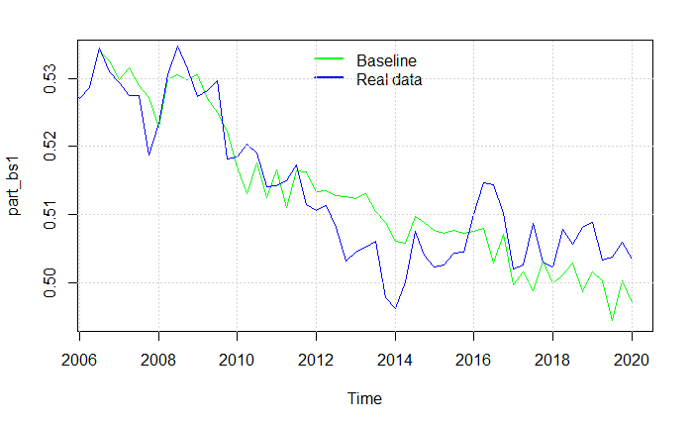

When removing the suppressing of the rate regulation rate we get almost the same results as in scenario 1. As the shock in scenario 1 had a minimum effect on the unemployment rate, the effect going into the labor force is also minimal creating almost no difference in the two scenarios. Therefor we also estimate the increase in unemployment to be approximately 150 people in this scenario. In scenario 5 when introducing all effects together, this channel will play a larger role.

# New productivity effect

As argued by (Chetty, 2008) 60% of the change in the unemployment period due to changes in the level of income insurance is caused by the liquidity effect. This creates a possible additional channel in the form of the matching effect, where increases in the level of income insurance affects the productivity as unemployed are more financially robust to stay longer time unemployed searching for a better job-match. As mentioned in section 3 empirical results are only finding weak evidence for the existing of the matching effect having an effect on the productivity, mostly in finding a realistic proxy for the productivity. The effect is included in the model by endogenizing the productivity function, using the level of income insurance per person as a regressor, as can be observed below. Also, the effect described by (Verdonn) will be included. We find significant results for both effects, like (Verdonn) We also control for wages as an explanation for a supply site factor explaining productivity, also here we find significant results.

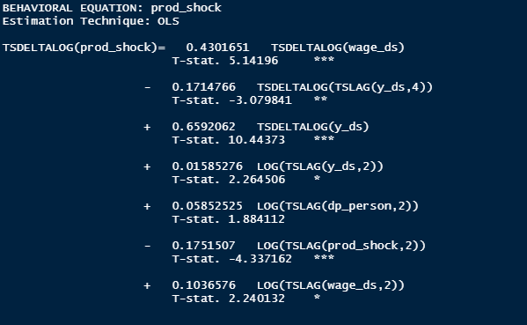

As the increase in the average level of income insurance now feeds directly into the productivity, we below observe an increase in productivity compared to the baseline model after 2016.

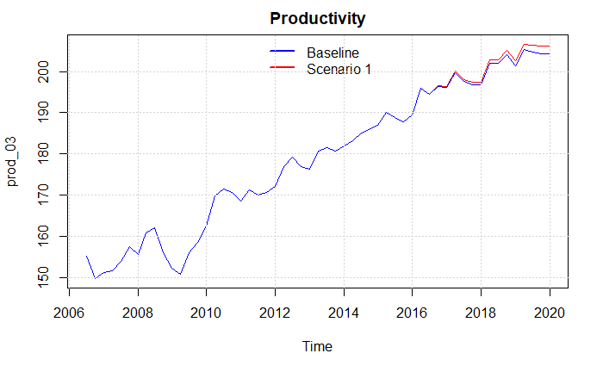

As the economy in a post-Keynesian SFC model is demand driven this goes for the labor market as well, therefor when increasing the productivity while having the same demand, firms will lower the number of workers to meet the same level of demand, therefor decreasing the number of employed in the economy by around 25.000 which is a 15 percent increase in the number of unemployed, at the same time we see an increase in the economic activity both observed in the plot below.

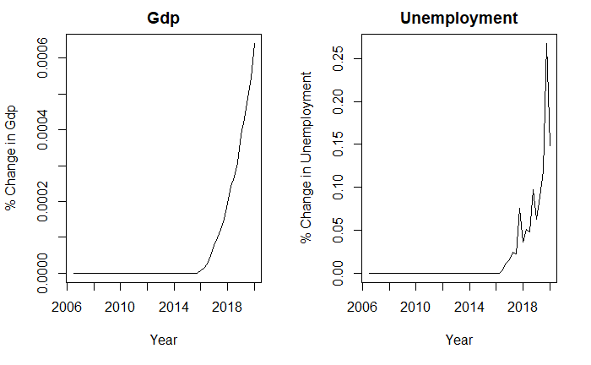

# Scenario 5 All effects

Using the results from the previous shocks we get a good indication of the independent results of each channel by including channels one by one to analyze how they affected the economy. Now, we will introduce a scenario including all the channels in the economy at once, doing this we allow the effects of channels to feed into other channels, thereby not making them independent of each other. We will focus on the effects on unemployment, Government net-lending and GDP and compare the results with the other scenarios. As the productivity channel is the one least empirically justified, we also look at a case where this is excluded.

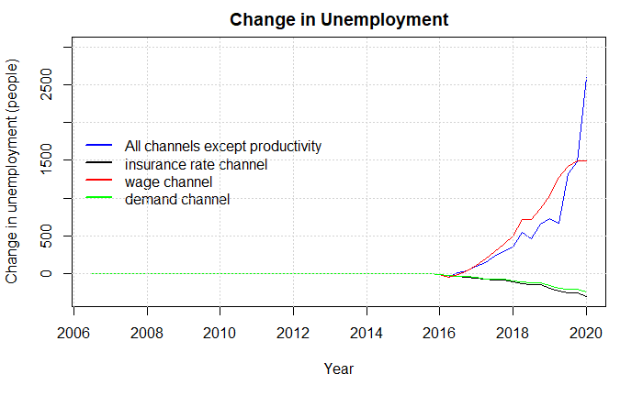

We can also look at the change in Government spendings here we see a large increase after 2018.

T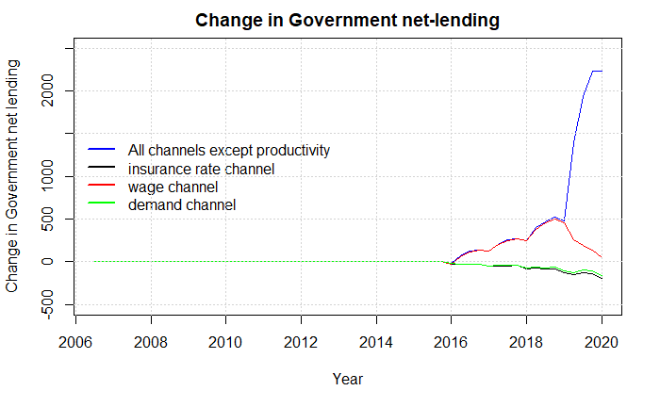

We can also compare the effects on GDP, also now including the case where productivity is included with all the other effects.

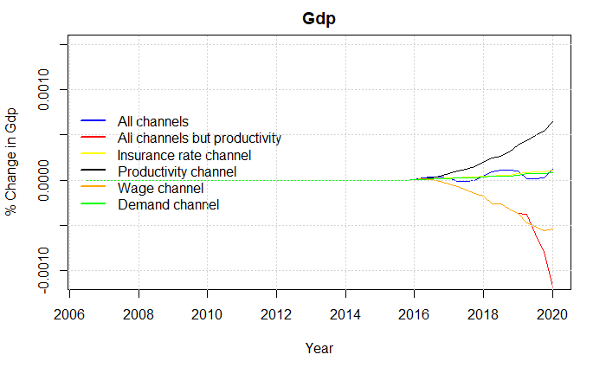

Isolating the case in which productivity is included we can also look at the effect on employment and net lending. Here we especially see how the productivity has a much larger effect on employment.

